



Problem – 1

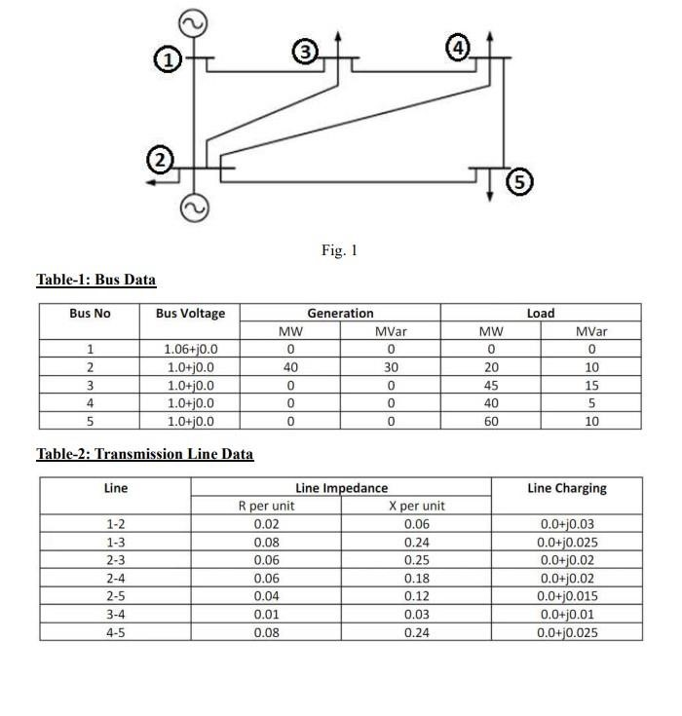

**Task-1**

**Perform load flow studies of the power system of Fig. 1 to identify slack bus (Bus no. 1) power and bus voltages (Bus no. 2 to Bus no. 3). Compute line flows and line losses also. [Use any simulation software]**

**Answer:**

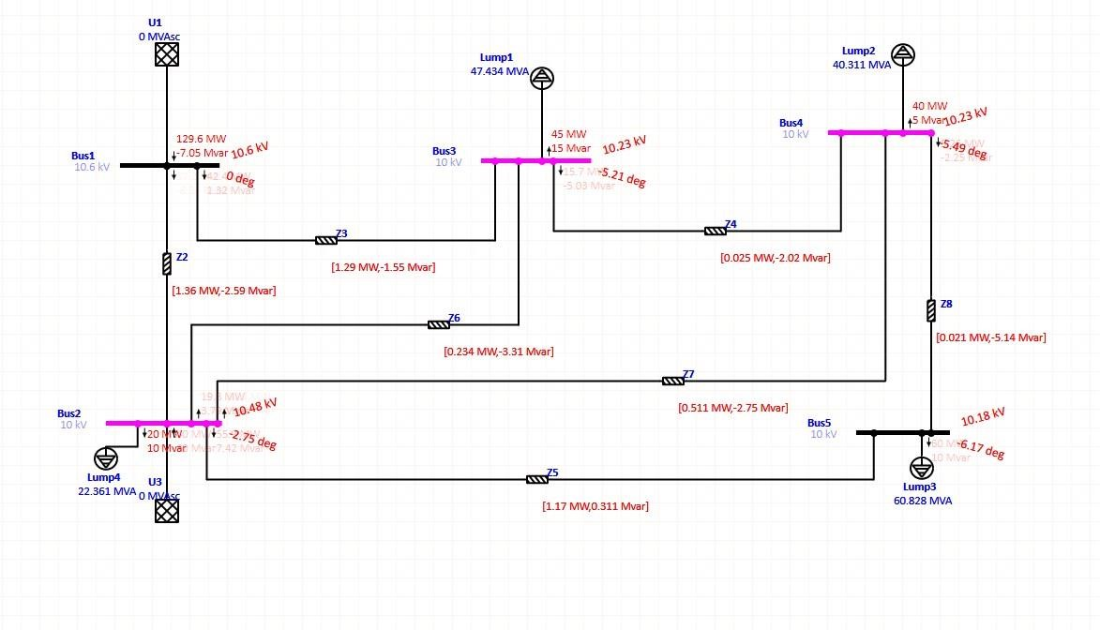

FIG 1: Simulation by ETAP

1. Here we used simulation software ETAP for our analysis
2. In the given figure The slack bus was bus no. 1, We here calculated line flows and line losses also.
3. Here instead of generator we used grid. The reason for that is When performing load flow analysis in software like ETAP the grid model represents the entire electrical network, including all its components and connections. This model considers the behavior and characteristics of the entire network, including load demand, power generation, and transmission losses. The grid model allows for a comprehensive analysis of the system, considering the overall stability, power flow, voltage profiles, and other parameters. But the generator only acts as an individual power source. Now this problem was IEEE 5 bus bar system. And by using grid we got more accurate solution than generator

**Analysis Result:**

Line flow and Line losses

|  |  |  |  |  |  |  |
| --- | --- | --- | --- | --- | --- | --- |
| Line | Ps(MW) | Qs(MVar) | Pr(MW) | Qr(MVar) | Ploss(MW) | Qloss(mvar) |
| 1-2 | 87.2 | -8.36 | 85.84 | -5.77 | 1.36 | -2.59 |
| 1-3 | 42.4 | 1.32 | 41.11 | 2.87 | 1.29 | -1.55 |
| 2-3 | 19.8 | 3.79 | 19.06 | 7.1 | 0.234 | -3.31 |
| 2-4 | 30.1 | 3.01 | 29.549 | 5.76 | 0.511 | -2.75 |
| 2-5 | 55.9 | 7.42 | 54.73 | 7.101 | 1.17 | 0.311 |
| 3-4 | 15.7 | -5.03 | 15.675 | -3.01 | 0.025 | -2.02 |
| 4-5 | 5.26 | -2.25 | 5.239 | 2.89 | 0.021 | -5.14 |

The slack bus power:

Real Power: 129.59

Reactive Power : -7.05 MVar

From Bus 2 to Bus 3:

|  |  |  |
| --- | --- | --- |
| BUS No. | Voltage | Angle |
| 2 | 1.048 | -2.75 |
| 3 | 1.023 | -5.21 |

**Task -2:**

**Verify the results obtained in Task no. 1 by writing a Matlab code adopting any load flow analysis method. Ans: clear all close all clc j = sqrt(-1);**

**Answer:**

% Enter data for forming admittance matrix

data = [1 2 0.02 0.06

1. 3 0.08 0.24
2. 3 0.06 0.25

2 4 0.06 0.18

1. 5 0.04 0.12
2. 4 0.01 0.03 4 5 0.08 0.24]; nl = data(:,1); % From which bus nr = data(:,2); % To which bus R = data(:,3); % Line resistance X = data(:,4); % Line reactance nbr = length(data(:,1)); % Number of branch nbus = max(max(nl), max(nr)); % Number of bus Z = R + j*X;

y = ones(nbr,1)./Z; % ./ performs element wise division

Ybus = zeros(nbus, nbus); % Off Diagonal element for k = 1:nbr

if not(nl(k) == nr(k))

Ybus(nl(k),nr(k)) = Ybus(nl(k), nr(k)) - y(k); Ybus(nr(k),nl(k)) = Ybus(nl(k),nr(k)); end end

% Diagonal element element

for n= 1 : nbus for k = 1 : nbr

if nl(k) == n || nr(k) ==n Ybus(n,n) = Ybus(n,n) + y(k);

end

end end Ybus

% For Load Bus Calculation

zdt = [1 0 0 0 0 1.06+j*0 2 .2 .10 .40 .30 1+j*0

1. .45 .15 0 0 1+j*0
2. .40 .05 0 0 1+j*0 5 .60 .10 0 0 1+j*0]; bn = zdt(:,1); % bus number Pl = zdt(:,2); % MW Load

Ql = zdt(:,3); % MVAR Load

Pg = zdt(:,4); % MW Generator

Qg = zdt(:,5); % MVAR Generator

V = zdt(:,6); % Bus Voltage

S = ones(4,-1); % Bus Voltage

for k=1:4

S(k) = (zdt(k+1,4) - zdt(k+1,2)) + (1j)*(zdt(k+1,5) - zdt(k+1,3));

end

S;

S_conj = conj(S)

V_conj = conj(V); iter = 0; max_iter = 500;

while iter < max_iter

for i = 2:5 sum = 0;

for k = 1:nbus

if k ~= i

sum = sum + Ybus(i,k)*V(k); sum; end sum;

end

V(i) = (1/Ybus(i,i))*((S_conj(i-1)/V_conj(i)) -sum);

V_conj(i) = conj(V(i));

end

iter = iter +1; end

V

V_conj = conj(V);

[theta, Voltage] = cart2pol(real(V), imag(V));

Voltage

Phase_Angle = rad2deg(theta);

Phase_Angle

%Voltage_conj = conj(Voltage); s = 0;

for i = 1:1:5 for k = 1:1:5 if i~=k

s = s + (Ybus(i,k)*V(k));

end end

S(i) = (V_conj(i)*((s) + (V(i)*Ybus(i,i))));

end

S;

Power_Slack_Bus = (real(S(1))*100) Q_Slack_Bus = (imag(S(1))*100)

z = conj(Z(1));

sq = ((V(1)-V(2))^2);

[theta, mag_1] = cart2pol(real(sq), imag(sq)); z_1 = conj(Z(1));

p_loss_Line_One_Two1 = ((mag_1/z_1)*100); p_loss_Line_One_Two = real(p_loss_Line_One_Two1) Q_loss_Line_One_Two = imag(p_loss_Line_One_Two1)

sq = ((V(1)-V(3))^2);

[theta, mag_1] = cart2pol(real(sq), imag(sq)); z_2 = conj(Z(2));

p_loss_Line_One_THREE1 = ((mag_1/z_2)*100); p_loss_Line_One_THREE = real (p_loss_Line_One_THREE1) Q_loss_Line_One_THREE = imag(p_loss_Line_One_THREE1)

sq = ((V(2)-V(3))^2);

[theta, mag_1] = cart2pol(real(sq), imag(sq)); z_3 = conj(Z(3));

p_loss_Line_tWO_THREE1 = ((mag_1/z_3)*100); p_loss_Line_tWO_THREE = real(p_loss_Line_tWO_THREE1) Q_loss_Line_tWO_THREE = imag(p_loss_Line_tWO_THREE1)

sq = ((V(2)-V(4))^2);

[theta, mag_1] = cart2pol(real(sq), imag(sq)); z_4 = conj(Z(4));

p_loss_Line_tWO_fOUR1 = ((mag_1/z_4)*100); p_loss_Line_tWO_fOUR = real(p_loss_Line_tWO_fOUR1) Q_loss_Line_tWO_fOUR = imag(p_loss_Line_tWO_fOUR1) sq = ((V(2)-V(5))^2);

[theta, mag_1] = cart2pol(real(sq), imag(sq)); z_5 = conj(Z(5));

p_loss_Line_TWO_fIVE1 = ((mag_1/z_5)*100); p_loss_Line_TWO_fIVE = real(p_loss_Line_TWO_fIVE1) Q_loss_Line_TWO_fIVE = imag(p_loss_Line_TWO_fIVE1)

sq = ((V(3)-V(4))^2);

[theta, mag_1] = cart2pol(real(sq), imag(sq)); z_6 = conj(Z(6));

p_loss_Line_tHREE_fOUR1 = ((mag_1/z_6)*100); p_loss_Line_tHREE_fOUR = real(p_loss_Line_tHREE_fOUR1) Q_loss_Line_tHREE_fOUR = imag(p_loss_Line_tHREE_fOUR1)

sq = ((V(4)-V(5))^2);

[theta, mag_1] = cart2pol(real(sq), imag(sq)); z_7 = conj(Z(7));

p_loss_Line_fOUR_fIVE1 = ((mag_1/z_7)*100); p_loss_Line_fOUR_fIVE = real(p_loss_Line_fOUR_fIVE1) Q_loss_Line_fOUR_fIVE = imag(p_loss_Line_fOUR_fIVE1)

Q_loss_Line_fOUR_fIVE =

0.0652

|  |  |  |  |  |
| --- | --- | --- | --- | --- |
| Bus | Voltage  (simulation) | Voltage (matlab) | Angle(simulation) | Angle (matlab) |
| 1 | 1.06 | 1.06 | 0 | 0 |
| 2 | 1.024 | 1.0367 | -2.75 | -2.5854 |
| 3 | 1.023 | 1.0071 | -5.21 | -5.0240 |
| 4 | 1.023 | 1.0059 | -5.49 | -5.2968 |
| 5 | 1.018 | 1.0012 | -6.17 | -5.9999 |
|  |  |  |  |  |

|  |  |  |  |  |
| --- | --- | --- | --- | --- |
| Branch | Power Loss (mat) | Power Loss (sim) | Reactive Loss(mat) | Reactive Loss(sim) |
| 1-2 | 1.3900 | 1.36 | -4.1701 | -2.59 |
| 1-3 | 1.3755 | 1.29 | -4.1285 | -1.55 |
| 2-3 | 0.2513 | 0.234 | -1.0475 | -3.31 |
| 2-4 | 0.5470 | 0.511 | -1.6409 | -2.75 |
| 2-5 | 1.2360 | 1.17 | 3.7080 | 0.311 |
| 3-4 | 0.0243 | 0.025 | -0.0728 | -2.02 |
| 4-5 | 0.0217 | 0.021 | -0.0652 | -5.14 |

**Task-3**

**Make an under voltage event in Bus-4 and apply any technique to overcome the under voltage problem of the system. (Consider, below 90% to be under voltage for any bus) .**

**Answer:**

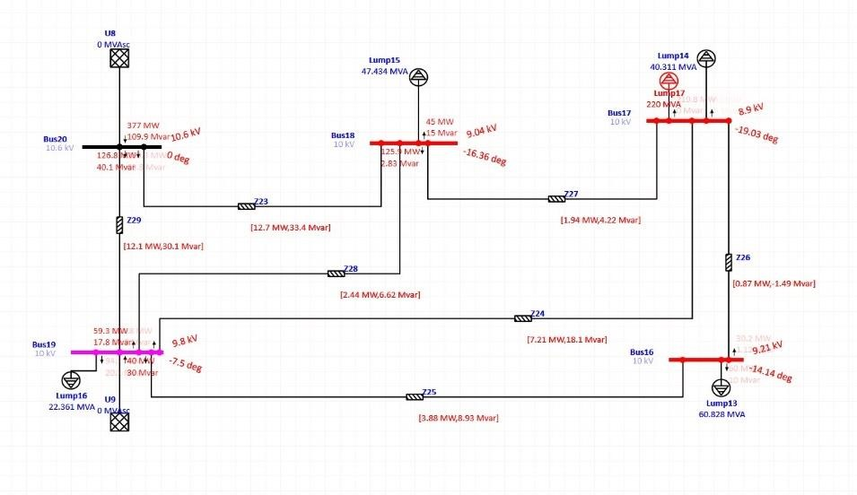

FIG: Making an under-voltage condition by adding a load

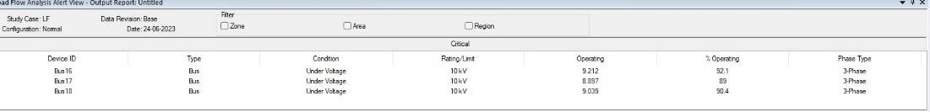

we can see that the ETAP software gives us a warning abouut under voltage in Bus-17 which is analogous to Bus-4 of our given problem.

Here we made the operating voltage under 90%, We can see that it is about 89%

To overcome this condition, we can adopt many steps

1. Static Shunt capacitor
2. Static Series capacitor
3. Synchronous compensator

In our analysis we used Shunt capacitor in Bus -4

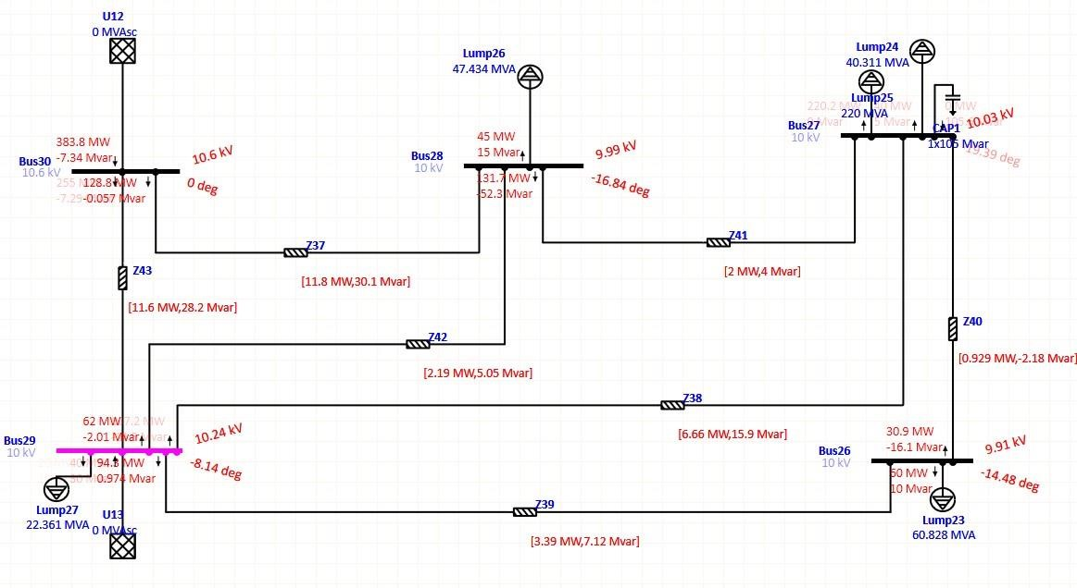

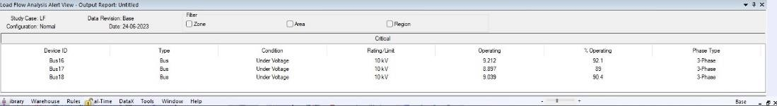

FIG: Solving the under-voltage by adding a capacitor

Adding a shunt capacitor

The value of the capacitor was given 105 MVAR

It solves the under-voltage problem

Here ETAP doesn't give any under voltage warning to BUS-27 which is analogous to BUS-4

So we have overcome the under-voltage problem

**Task-4**

**If the power flow through the transmission line (2-5) is to be made 75% of the normal condition, what should be the steps that can be adopted to do it? Implement any of them to do this job.**

**Answer:**

Here we did it in two ways

1. Increasing the reactance
2. Adding a transformer

Increasing the reactance

The Transmission line reactance from bus bar 2 to bus bar 5 was about 0.12 or 12%, The reactance value was changed to a higher value to make the power flow less

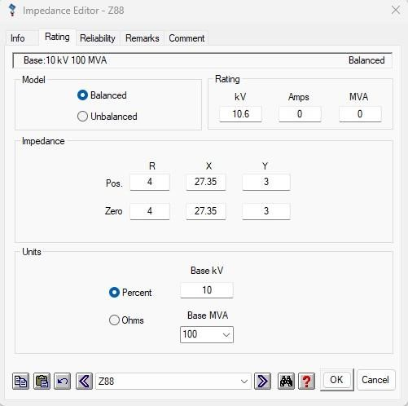

The reactance value was changed from 12% to 27.35% to exactly make the power flow 75% previously the power flow was 55.9 MW then it changed to 41.9 MW

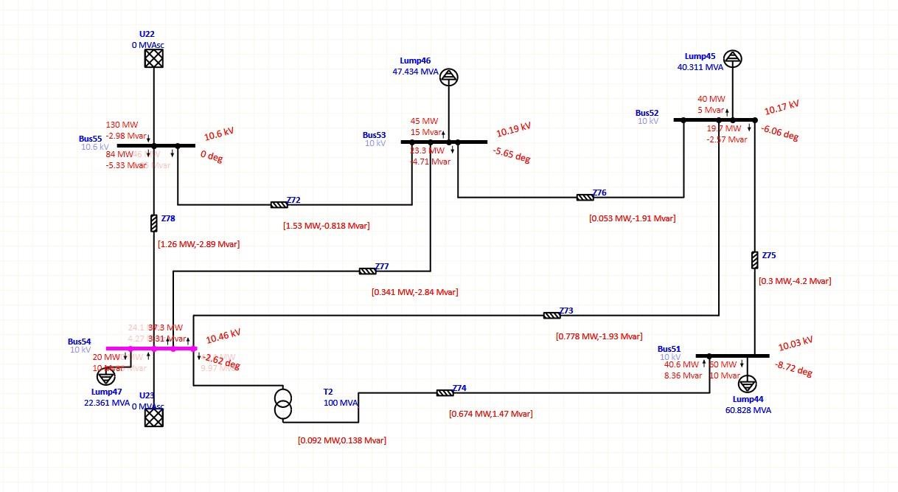

Here we added a transformer now the voltage power flow became 41.4 of actual flow 55.9 We almost made 75% of power flow

Analysis Result

|  |  |  |
| --- | --- | --- |
| Methods | Previous | New |
| Increasing Reactance | 55.9 | 41.9 |
| Adding Transformer | 55.9 | 41.4 |

**Summary:**

Here we used software to simulate our analysis and compared the result with the result obtained from matlab. Then we created a undervoltage situation and solved the situation by using capacitor and we used transformer to adjust power flow. The result from code and simulation was not same. There could be limitation of the method we used.

.

**Reference Link:**

1. [*Power System Analysis Hadi Sadat Toolbox.rar*. (n.d.). Google Docs.](https://www.scribbr.com/citation/generator/folders/2zQcif6b6qHOioHEKLf48B/lists/2ktFuUpNcpTEVvNf1PsS4o/sources/3Wv4qXAJ93htOz41YWYnPf/)

[https://drive.google.com/file/d/1kx7qsX-Dl0l33Zo8QeeQM9Eyn9f0OQi3/view](https://www.scribbr.com/citation/generator/folders/2zQcif6b6qHOioHEKLf48B/lists/2ktFuUpNcpTEVvNf1PsS4o/sources/3Wv4qXAJ93htOz41YWYnPf/)

1. *IEEE 5 bus data*. (n.d.). Scribd. [https://www.scribd.com/document/419462308/IEEE5-bus-data](https://www.scribd.com/document/419462308/IEEE-5-bus-data)